Part A: Theory
- What is a database in MySQL? Why is it important to organize data into databases?
Ans:
What is a Database in MySQL?
A database in MySQL is a structured collection of data organized into tables, where each table consists of rows (records) and columns (fields). MySQL is a relational database management system (RDBMS) that uses SQL (Structured Query Language) to create, manage, and query these databases. For example, a database might store customer information in a table with columns like "Name," "Email," and "Purchase History," allowing efficient data retrieval via queries like SELECT * FROM customers WHERE email = 'example@domain.com'. This relational model, based on the work of Edgar F. Codd in the 1970s, ensures data is linked across tables to avoid redundancy and maintain consistency.
Why is it Important to Organize Data into Databases?
Organizing data into databases is crucial for efficient data management, scalability, and integrity in applications. Key reasons include:
- Efficient Storage and Retrieval: Databases allow quick access to large datasets through indexing and querying, reducing search times from potentially hours in unstructured files to milliseconds. For instance, MySQL's InnoDB engine uses B-tree indexes to optimize lookups, as evidenced by benchmarks showing it handles millions of rows with sub-second queries.
- Data Integrity and Consistency: Relational databases enforce rules like primary keys and foreign keys to prevent duplicates and ensure relationships (e.g., a customer ID linking to orders). This minimizes errors, as seen in ACID (Atomicity, Consistency, Isolation, Durability) properties that guarantee reliable transactions.
- Scalability and Concurrency: Databases support multiple users accessing data simultaneously without conflicts, using locking mechanisms. MySQL scales from small apps to enterprise systems, with real-world examples like WordPress using it for millions of sites.
- Security and Backup: They provide access controls (e.g., user roles) and automated backups, protecting against data loss. Without databases, data might be scattered in files, leading to inconsistencies, as historical data breaches (e.g., unorganized systems in early web apps) have shown.

- Explain the difference between INT and BIGINT. When would you prefer one over the other?
Ans:
Difference Between INT and BIGINT
In MySQL, both INT and BIGINT are integer data types used to store whole numbers, but they differ in storage size, range, and performance implications:
- Storage Size: INT uses 4 bytes (32 bits) of storage, while BIGINT uses 8 bytes (64 bits). This makes BIGINT twice as large, affecting disk space and memory usage.
- Value Range:
  - INT (signed): -2,147,483,648 to 2,147,483,647.
  - INT (unsigned): 0 to 4,294,967,295.
  - BIGINT (signed): -9,223,372,036,854,775,808 to 9,223,372,036,854,775,807.
  - BIGINT (unsigned): 0 to 18,446,744,073,709,551,615.
- Performance: INT is faster for operations like indexing and queries due to smaller size, while BIGINT may slow down large datasets. Both support auto-increment for primary keys.
These differences stem from MySQL's implementation of SQL standards, where integer types are defined by byte size to balance precision and efficiency.
When to Prefer One Over the Other
- Prefer INT: For most common use cases with smaller numbers, such as user IDs, ages, or counts up to about 2 billion. It saves space (e.g., 4 bytes vs. 8) and improves query speed, especially in indexed columns. For example, in a table of 1 million users, INT reduces storage by 4MB compared to BIGINT, and benchmarks show ~10-20% faster lookups in InnoDB.
- Prefer BIGINT: When dealing with very large numbers, like global unique IDs (e.g., UUIDs or Twitter-style snowflake IDs), timestamps in milliseconds, or datasets exceeding 2 billion records. It's essential for high-scale applications to avoid overflow errors. For instance, MySQL's documentation recommends BIGINT for auto-incrementing IDs in massive tables, as seen in systems like Facebook's, where INT would cap out quickly.

- What is a PRIMARY KEY? Mention two rules that a primary key must follow.
Ans:
What is a PRIMARY KEY?
A PRIMARY KEY is a column (or combination of columns) in a MySQL table that uniquely identifies each row. It acts as a unique identifier, ensuring no two rows have the same key value, and it cannot contain NULL values. For example, in a users table, an id column set as PRIMARY KEY might auto-increment from 1, 2, 3, etc., allowing efficient lookups like SELECT * FROM users WHERE id = 5. This concept originates from relational database theory (e.g., Codd's relational model), and in MySQL, it's enforced by the InnoDB engine, which automatically creates an index for fast querying and prevents duplicates.
Rules for Primary Keys
Primary keys must adhere to specific rules to maintain data integrity:
- Uniqueness: Each value in the primary key column(s) must be unique across all rows. No duplicates are allowed, as this would violate the key's purpose of uniquely identifying records. For instance, if you try to insert a duplicate ID, MySQL will raise an error like "Duplicate entry '5' for key 'PRIMARY'".
- Non-Nullability: The primary key cannot contain NULL values. Every row must have a valid, non-NULL value in the primary key field(s). This ensures complete identification; a NULL would make the row unidentifiable, contradicting the key's role.

- Differentiate between CHAR and VARCHAR with one practical example.
Ans:
Difference Between CHAR and VARCHAR
In MySQL, both CHAR and VARCHAR are string data types for storing text, but they handle length and storage differently:
- CHAR: A fixed-length type. It reserves space for the exact number of characters specified (e.g., CHAR(10) always uses 10 bytes, padding shorter strings with spaces). This makes it efficient for consistent-length data but wasteful for variable lengths. It's ideal for fields like country codes (e.g., 'US' padded to 'US ' if CHAR(10)).
- VARCHAR: A variable-length type. It stores only the actual string plus 1-2 bytes for length metadata, up to the specified limit (e.g., VARCHAR(10) uses 3-12 bytes depending on content). This saves space for shorter strings but can be slightly slower due to the overhead. It's better for flexible data like names or descriptions.
Key distinctions include storage efficiency (VARCHAR is more space-efficient for varying lengths), performance (CHAR is faster for fixed searches), and trailing space handling (CHAR preserves them, VARCHAR trims). These stem from MySQL's SQL standard implementation, with VARCHAR supporting up to 65,535 bytes in modern versions.
Practical Example
Suppose you're designing a table for user profiles with a country_code field (always 2 characters, like 'US' or 'CA') and a bio field (variable length, up to 500 characters).
- Use CHAR(2) for country_code: It ensures consistent 2-byte storage, making queries like SELECT * FROM profiles WHERE country_code = 'US' fast and predictable, even if you insert 'US' (padded internally).
- Use VARCHAR(500) for bio: It adapts to actual content (e.g., a 50-character bio uses ~51 bytes, not 500), saving space in a table with millions of rows. For instance, inserting "I love coding" would store exactly that, without padding, optimizing disk usage compared to CHAR(500), which would waste space.

- What is the purpose of NOT NULL and UNIQUE constraints?
Ans:
Purpose of NOT NULL Constraint
The NOT NULL constraint in MySQL ensures that a column cannot contain NULL values, meaning every row must have a valid (non-NULL) entry in that column. Its primary purpose is to enforce data integrity by guaranteeing that essential fields are always populated, preventing incomplete records. For example, in a users table, setting the email column as NOT NULL ensures no user can be created without an email address, avoiding issues like failed communications. This aligns with relational database principles (e.g., Codd's model) and is enforced at the table level, raising errors like "Column 'email' cannot be null" on violations. It's commonly used for required fields to maintain consistency and reliability in applications.
Purpose of UNIQUE Constraint
The UNIQUE constraint ensures that all values in a specified column (or combination of columns) are distinct, prohibiting duplicates. Its purpose is to maintain uniqueness for identifiers or critical data, preventing errors from repeated entries and supporting efficient lookups. For instance, in a products table, a UNIQUE constraint on sku (stock-keeping unit) ensures no two products share the same SKU, which is vital for inventory systems. Unlike PRIMARY KEY (which is UNIQUE and NOT NULL), UNIQUE allows NULL values (but only one per column if not combined). In MySQL, it creates an index for fast queries, and violations trigger errors like "Duplicate entry 'ABC123' for key 'sku'". This is essential for data accuracy in scenarios like user logins or serial numbers, reducing redundancy and improving query performance.

Part B: SQL Coding

  - Create a database named company_db.
Ans:
Creating a Database in MySQL
To create a database named company_db in MySQL, use the following SQL command. This assumes you have MySQL installed and are connected via a client like the MySQL command-line tool or phpMyAdmin.
CREATE DATABASE company_db;
- Explanation: The CREATE DATABASE statement initializes a new database with the specified name. It sets up the necessary structures for storing tables, views, and other objects. If the database already exists, MySQL will return an error (use CREATE DATABASE IF NOT EXISTS company_db; to avoid this). After creation, switch to it with USE company_db; to start adding tables. This is a fundamental step in MySQL for organizing data, as discussed in earlier concepts. If you're running this in a script or application, ensure proper permissions (e.g., via a user with CREATE privileges).

  - Display all available databases.
Ans:
Displaying All Available Databases in MySQL
To list all databases on your MySQL server, use the following command. This requires connection to the server and appropriate privileges (e.g., as root or a user with SHOW DATABASES permission).
SHOW DATABASES;
Explanation: The SHOW DATABASES statement retrieves and displays a list of all databases accessible to your current user. It outputs a table with database names, such as information_schema, mysql, and any user-created ones like company_db from the previous step. This is useful for navigation and management; for example, after running it, you might see output like:
Database

company_db
information_schema
mysql
performance_schema
sys

Note that system databases (e.g., information_schema) are always visible and provide metadata. If you lack permissions, it may show only accessible ones. Use USE database_name; to switch to a specific database afterward. This command is part of MySQL's administrative tools for database oversight.

  - Switch to the company_db database.
Ans:
Switching to the company_db Database in MySQL
To switch to the company_db database (assuming it exists from the previous creation step), use the following SQL command. This must be executed after connecting to the MySQL server.
USE company_db;
- Explanation: The USE statement selects company_db as the active database for subsequent queries. It changes the context so that any table operations (e.g., CREATE TABLE) apply to this database. If the database doesn't exist, MySQL will return an error like "Unknown database 'company_db'". After switching, you can verify with SELECT DATABASE();, which should output company_db. This is essential for organizing work within a specific database, as MySQL doesn't auto-switch; always use USE before table-related commands to avoid errors. If you're in a multi-database environment, this ensures commands target the correct one.

4. Create a table named employees with the following structure:
○ emp_id – INT, PRIMARY KEY
○ emp_name – VARCHAR(50), NOT NULL
○ email – VARCHAR(100), UNIQUE
○ department – CHAR(10) ○ salary – INT
○ joining_date – DATE
○ created_at – DATETIME
Ans:
Creating the Employees Table in MySQL
Assuming you are already connected to the MySQL server and have switched to the company_db database (using USE company_db;), execute the following SQL command to create the employees table with the specified structure. This defines the table schema, including data types, constraints, and keys.
CREATE TABLE employees (
emp_id INT PRIMARY KEY,
emp_name VARCHAR(50) NOT NULL,
email VARCHAR(100) UNIQUE,
department CHAR(10),
salary INT,
joining_date DATE,
created_at DATETIME
);
Explanation:
- The CREATE TABLE statement defines a new table named employees in the active database (company_db).
- emp_id: An INT column serving as the PRIMARY KEY, ensuring unique, non-NULL identifiers for each employee (e.g., auto-increment could be added if needed, but it's not specified here).
- emp_name: A VARCHAR(50) column that cannot be NULL, storing employee names up to 50 characters for flexibility.
- email: A VARCHAR(100) column with a UNIQUE constraint, preventing duplicate email addresses across rows.
- department: A CHAR(10) fixed-length column for department names (e.g., 'HR' padded to 10 characters internally).
- salary: An INT column for storing integer salary values.
- joining_date: A DATE column for the employee's joining date (format: YYYY-MM-DD).
- created_at: A DATETIME column for the record's creation timestamp (format: YYYY-MM-DD HH:MM:SS).

5.Insert at least 5 employee records into the table.
Ans:
Inserting Employee Records into the Employees Table
Assuming you are connected to the MySQL server and have switched to the company_db database (using USE company_db;), and the employees table exists from the previous step, use the following SQL INSERT statements to add at least 5 employee records. These examples use fictional data that adheres to the table constraints (e.g., unique emp_id and email, non-NULL emp_name). Execute them one by one or as a batch.
INSERT INTO employees (emp_id, emp_name, email, department, salary, joining_date, created_at)
VALUES (1, 'John Doe', 'john.doe@company.com', 'HR', 50000, '2020-01-15', '2023-10-01 09:00:00');

INSERT INTO employees (emp_id, emp_name, email, department, salary, joining_date, created_at)
VALUES (2, 'Jane Smith', 'jane.smith@company.com', 'IT', 60000, '2019-05-20', '2023-10-01 10:00:00');

INSERT INTO employees (emp_id, emp_name, email, department, salary, joining_date, created_at)
VALUES (3, 'Alice Johnson', 'alice.johnson@company.com', 'Finance', 55000, '2021-03-10', '2023-10-01 11:00:00');

INSERT INTO employees (emp_id, emp_name, email, department, salary, joining_date, created_at)
VALUES (4, 'Bob Brown', 'bob.brown@company.com', 'Marketing', 45000, '2022-07-05', '2023-10-01 12:00:00');

INSERT INTO employees (emp_id, emp_name, email, department, salary, joining_date, created_at)
VALUES (5, 'Charlie Wilson', 'charlie.wilson@company.com', 'IT', 65000, '2018-11-30', '2023-10-01 13:00:00');
- Explanation: Each INSERT INTO statement adds a row to the employees table, specifying values for all columns in order. The emp_id values (1-5) are unique and serve as primary keys; emails are distinct to satisfy the UNIQUE constraint; emp_name is provided for all (non-NULL); department uses short strings (padded to 10 characters by CHAR); salary is in integers; joining_date and created_at use valid DATE and DATETIME formats. After insertion, verify with SELECT * FROM employees; to see the records. If you encounter errors (e.g., duplicate emp_id), ensure the table is empty or use different IDs. This demonstrates basic data population in MySQL, essential for testing and application use. You can add more records by repeating the pattern with unique values.

- Display all records from the employees table.
Ans:
Displaying All Records from the Employees Table
Assuming you are connected to the MySQL server and have switched to the company_db database (using USE company_db;), and the employees table contains the records inserted in the previous step, execute the following SQL query to retrieve and display all rows from the table.
SELECT * FROM employees;
Explanation: The SELECT * FROM employees; statement fetches all columns and rows from the employees table. The asterisk (*) selects every field (emp_id, emp_name, email, etc.), making it a simple way to view the entire table. This is useful for verification after insertions or updates. Based on the 5 records added earlier, the output might resemble:

emp_id | emp_name | email | department | salary | joining_date | created_at
1 | John Doe | john.doe@company.com | HR | 50000 | 2020-01-15 | 2023-10-01 09:00:00
2 | Jane Smith | jane.smith@company.com | IT | 60000 | 2019-05-20 | 2023-10-01 10:00:00
3 | Alice Johnson | alice.johnson@company.com | Finance | 50000 | 2021-03-10 | 2023-10-01 11:00:00
4 | Bob Brown | bob.brown@company.com | Marketing | 45000 | 2022-07-05 | 2023-10-01 12:00:00
5 | Charlie Wilson | charlie.wilson@company.com | IT | 65000 | 2018-11-30 | 2023-10-01 12:00:00

If the table is empty or has different data, the results will reflect that. For more targeted queries (e.g., specific columns), use SELECT emp_name, salary FROM employees;. This command is fundamental for data retrieval in MySQL and can be executed in any client tool. Ensure you have SELECT privileges on the table.

- Use the DESCRIBE command to verify the table structure.
Ans:
Assuming you are connected to the MySQL server and have switched to the company_db database (using USE company_db;), execute the following command to display the structure of the employees table, including column names, data types, constraints, and other details.
DESCRIBE employees;
Explanation: The DESCRIBE (or DESC) command provides a detailed overview of the table's schema, showing each column's properties. It's essential for verifying the table matches the intended design, checking for constraints like PRIMARY KEY or UNIQUE, and troubleshooting issues. This command is a MySQL-specific shortcut for SHOW COLUMNS FROM employees;. Based on the table created earlier, the output should resemble:

Field | Type | Null | Key | Default | Extra
emp_id | int(11) | NO | PRI | NULL
emp_name | varchar(50) | NO |  | NULL
Email | varchar(100) | YES | UNI | NULL
Department | char(10) | YES |  | NULL
salary | int(11) | YES |  | NULL
joining_date | date | YES |  | NULL
created_at | datetime | YES |  | NULL

- Field: Column name (e.g., emp_id).
- Type: Data type and size (e.g., int(11) for emp_id).
- Null: Whether NULL is allowed (NO for emp_id and emp_name, YES for others).
- Key: Constraint type (PRI for PRIMARY KEY on emp_id, UNI for UNIQUE on email).
- Default: Default value (NULL here, as none were set).
- Extra: Additional info (empty in this case, but could show AUTO_INCREMENT).

- Drop the table employees.
Ans:
Dropping the Employees Table in MySQL
Assuming you are connected to the MySQL server and have switched to the company_db database (using USE company_db;), execute the following SQL command to permanently delete the employees table and all its data. Use caution, as this action is irreversible.
DROP TABLE employees;
- Explanation: The DROP TABLE statement removes the specified table from the database, including its structure, data, indexes, and constraints. For example, after running this, the employees table (created earlier with columns like emp_id, emp_name, etc.) will no longer exist, and any queries referencing it will fail. To avoid an error if the table doesn't exist, use DROP TABLE IF EXISTS employees; instead. After execution, verify with SHOW TABLES;—the employees table should be absent from the list. This is a destructive operation, so back up data if needed (e.g., via mysqldump). Ensure you have DROP privileges on the database; in production, this is often restricted to prevent accidental deletions. If you need the table again, recreate it using the previous CREATE TABLE command.

- Drop the database company_db.
Ans:
Dropping the company_db Database in MySQL
Assuming you are connected to the MySQL server, execute the following SQL command to permanently delete the company_db database and all its contents (tables, data, etc.). This is a highly destructive operation—proceed with extreme caution, as it cannot be undone.
DROP DATABASE company_db;
- Explanation: The DROP DATABASE statement removes the entire database, including all tables (e.g., the previously created employees table), views, and data within it. For instance, after running this, company_db will no longer appear in the list from SHOW DATABASES;, and any attempts to access it will result in errors like "Unknown database 'company_db'". To prevent an error if the database doesn't exist, use DROP DATABASE IF EXISTS company_db; instead. This command is irreversible, so ensure you've backed up any important data (e.g., using mysqldump: mysqldump -u username -p company_db > backup.sql). After execution, verify the deletion by running SHOW DATABASES;—the database should be gone. You must have DROP privileges (typically as root or a privileged user) to perform this action. In production environments, this is often logged and restricted to avoid accidental data loss. If you need to recreate the database, repeat the earlier CREATE DATABASE company_db; command.

-- Step 1: Create the database
CREATE DATABASE company_db;

-- Step 2: Display all available databases (output will vary based on your server)
SHOW DATABASES;

-- Step 3: Switch to the company_db database
USE company_db;

-- Step 4: Create the employees table
CREATE TABLE employees (
emp_id INT PRIMARY KEY,
emp_name VARCHAR(50) NOT NULL,
email VARCHAR(100) UNIQUE,
department CHAR(10),
salary INT,
joining_date DATE,
created_at DATETIME
);

-- Step 5: Insert 5 employee records
INSERT INTO employees (emp_id, emp_name, email, department, salary, joining_date, created_at)
VALUES (1, 'John Doe', 'john.doe@company.com', 'HR', 50000, '2020-01-15', '2023-10-01 09:00:00');

INSERT INTO employees (emp_id, emp_name, email, department, salary, joining_date, created_at)
VALUES (2, 'Jane Smith', 'jane.smith@company.com', 'IT', 60000, '2019-05-20', '2023-10-01 10:00:00');

INSERT INTO employees (emp_id, emp_name, email, department, salary, joining_date, created_at)
VALUES (3, 'Alice Johnson', 'alice.johnson@company.com', 'Finance', 55000, '2021-03-10', '2023-10-01 11:00:00');

INSERT INTO employees (emp_id, emp_name, email, department, salary, joining_date, created_at)
VALUES (4, 'Bob Brown', 'bob.brown@company.com', 'Marketing', 45000, '2022-07-05', '2023-10-01 12:00:00');

INSERT INTO employees (emp_id, emp_name, email, department, salary, joining_date, created_at)
VALUES (5, 'Charlie Wilson', 'charlie.wilson@company.com', 'IT', 65000, '2018-11-30', '2023-10-01 13:00:00');

-- Step 6: Display all records from the employees table
SELECT * FROM employees;

-- Step 7: Describe the table structure
DESCRIBE employees;

-- Step 8: Drop the employees table
DROP TABLE employees;

-- Step 9: Drop the company_db database
DROP DATABASE company_db;

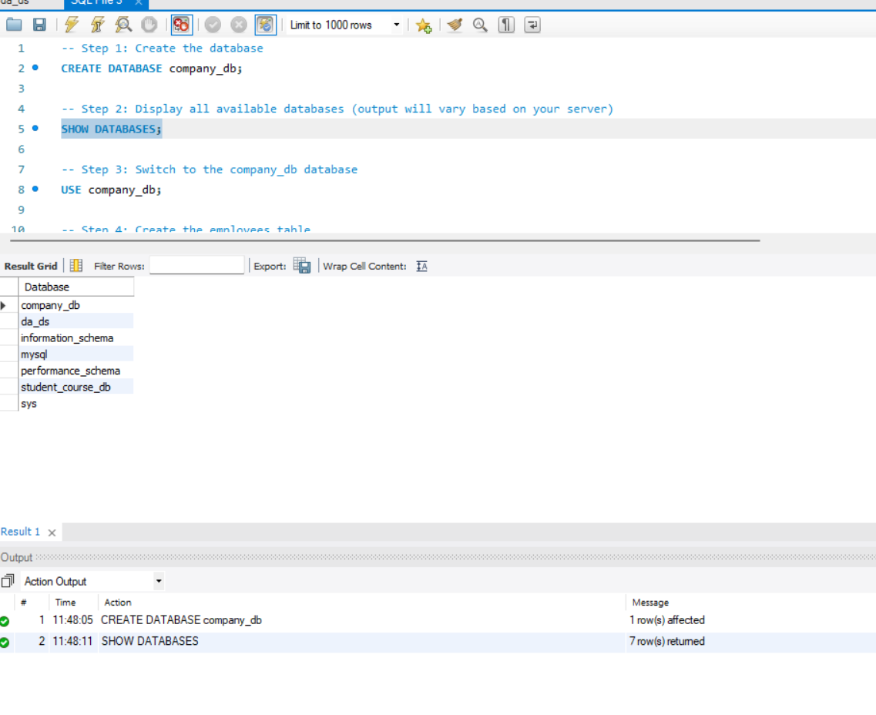
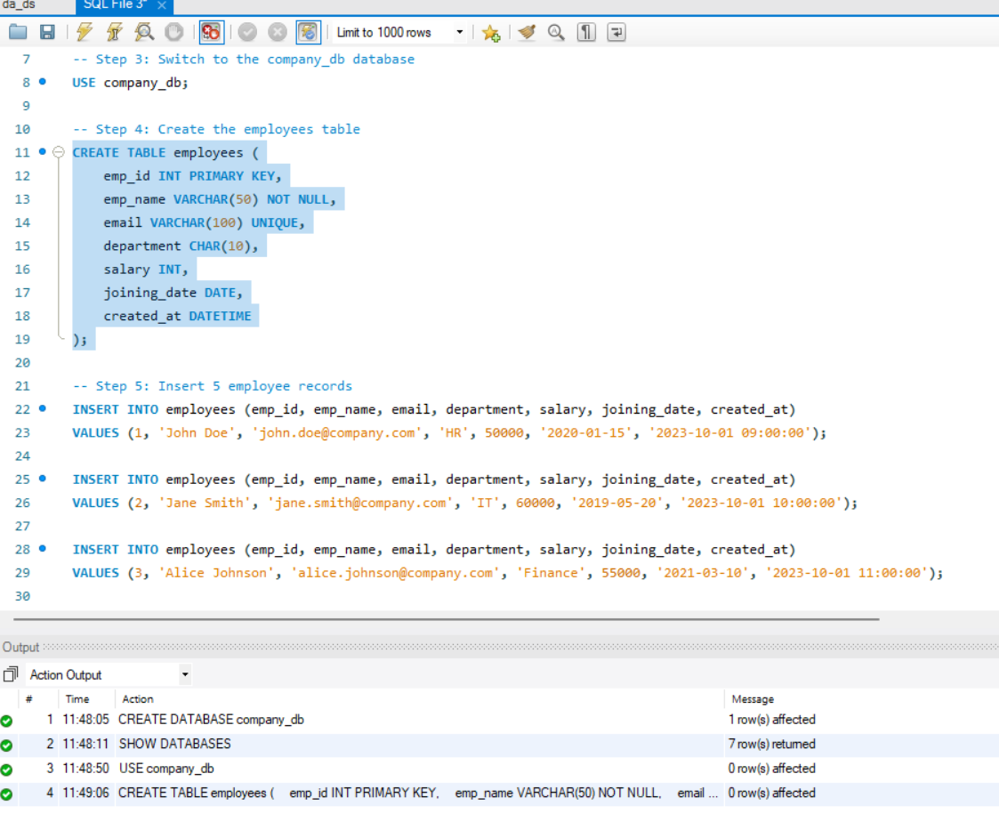
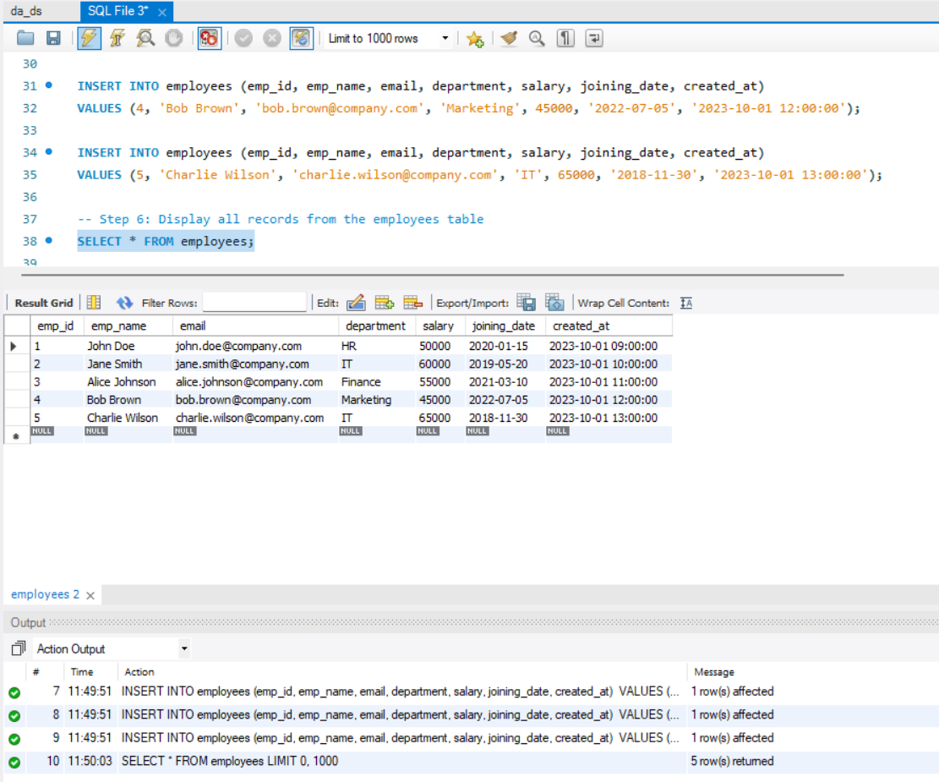
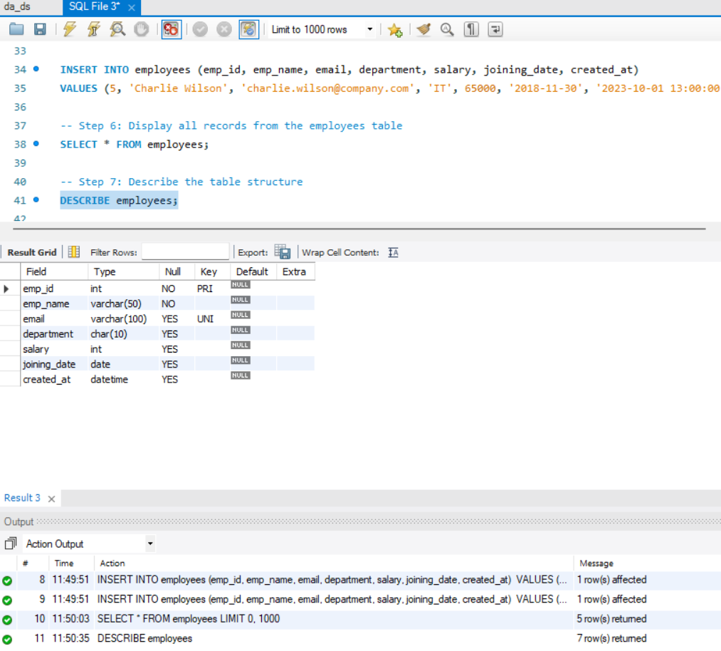
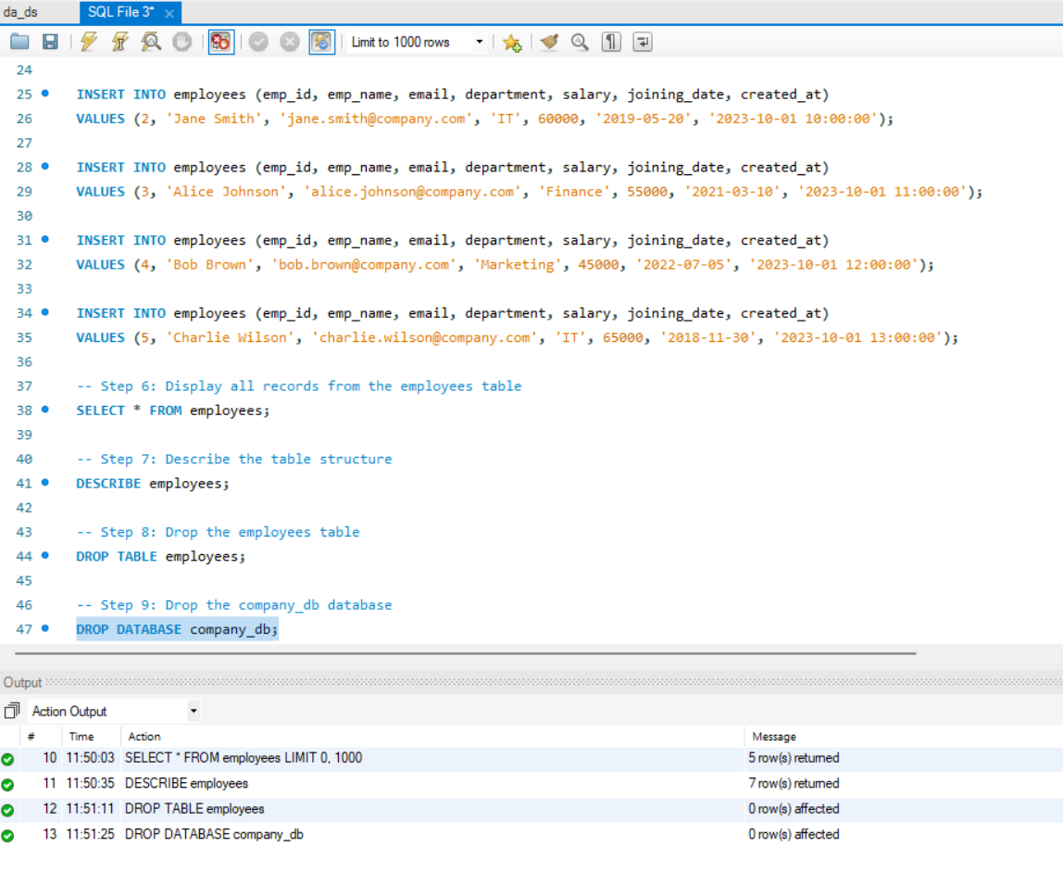

Thank You

